### **A Journey Through Lake Como**

### **May 28, 2025**

Lake Como in Northern Italy has a way of making you feel like you’ve stepped into a living postcard. My girlfriend and I spent seven days in the town of Como. We stayed in a cozy apartment, just three blocks from the ferry terminal. This central location proved to be the perfect home base for all our adventures, allowing us to easily immerse ourselves in the local culture and explore the breathtaking landscapes that surrounded us.

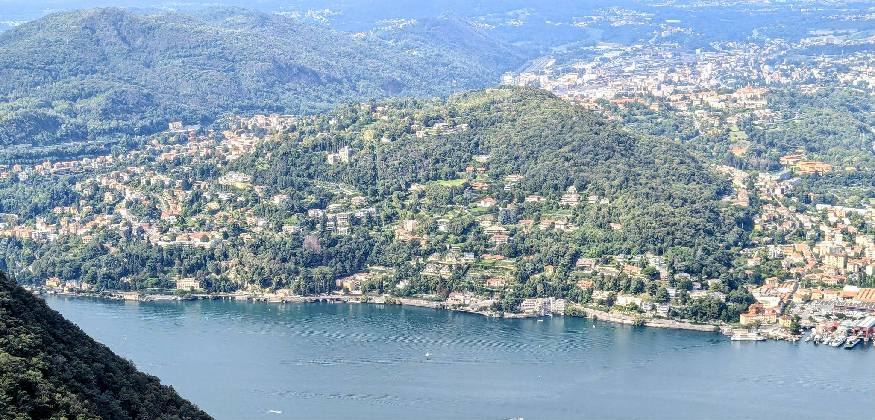

Como’s Lakeside

The beauty of Lake Como is not just in its famous waters, but in the unique blend of natural wonder and architectural charm. We made a point to explore the town of Como itself on foot, wandering through beautiful piazzas, tree-lined parks, and the impressive Como Cathedral with its ornate Gothic façade. The lakeside promenade quickly became a daily ritual—especially in the evenings when the air cooled, the light softened, and the sunset painted the water in gold and pink. Como has this wonderful mix of energy and tranquility, where you can wander without a plan and still stumble across hidden gems like artisan shops, old fountains, or bakeries serving fresh pastries.

*Travel Tip:* The best time for a lakeside stroll is just before sunset. Not only is the light magical for photos, but the locals are out enjoying their evening passeggiata, making for a lively, authentic atmosphere.

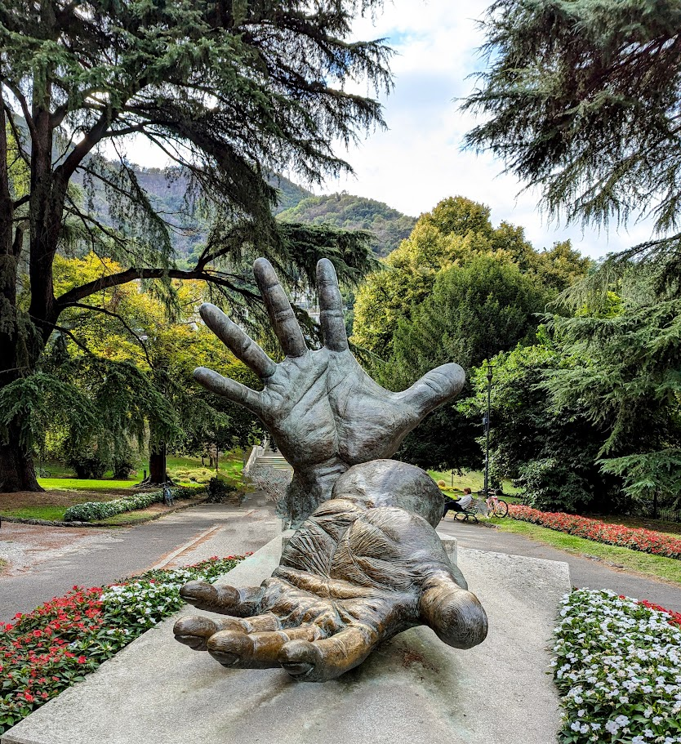

One of our early adventures was riding the historic funicular from Como up to Brunate. The funicular has been in operation since 1894 and is a popular attraction for both tourists and locals. The slow climb revealed sweeping views of the lake and the charming rooftops below, and at the top, we were treated to panoramic vistas that looked like they belonged in an art gallery. Brunate itself was quiet and peaceful, with flower-lined streets and the kind of little cafés where time seemed to slow. It was the perfect way to get a sense of the scale and beauty of the region.

*Travel Tip:* Sit on the right side of the funicular when going up to get the best lake views.

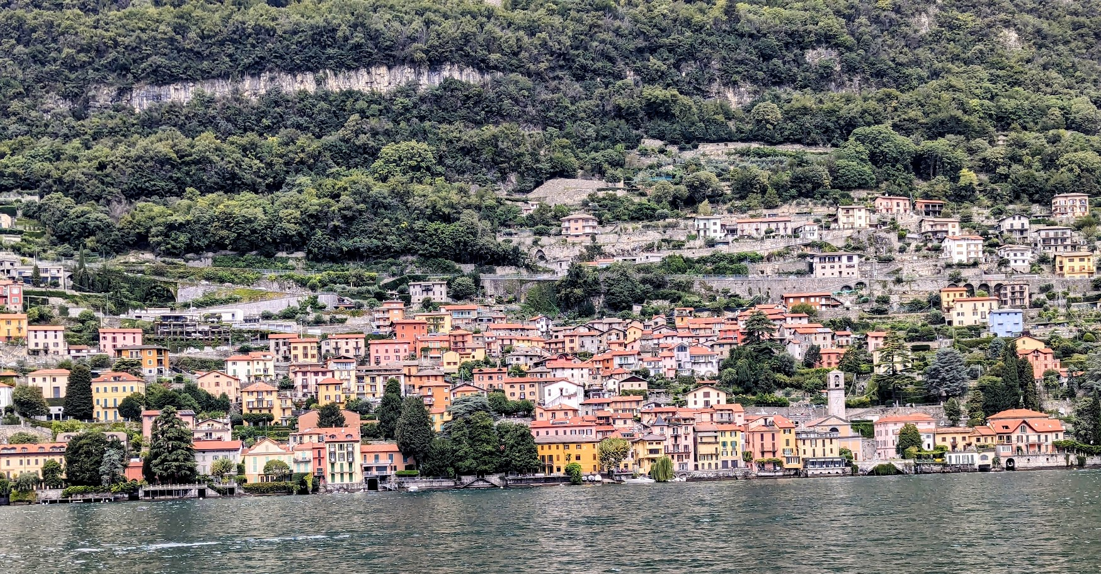

Lake Como

A highlight of our trip was exploring the other picturesque villages by water. We dedicated a day to a ferry trip to Bellagio, a village often referred to as the "Pearl of Lake Como." The ferry ride itself was a treat, providing a leisurely and scenic journey along the shoreline, dotted with elegant villas and lush gardens. Bellagio’s cobblestone streets zigzag up the hill, each turn revealing boutique shops, and restaurants. The stunning views from every corner of the village confirmed its reputation as a must-visit spot on the lake.

*Travel Tip:* Take the morning ferry to Bellagio to avoid the busiest crowds, and wear comfortable shoes—the streets are steep and cobbled.

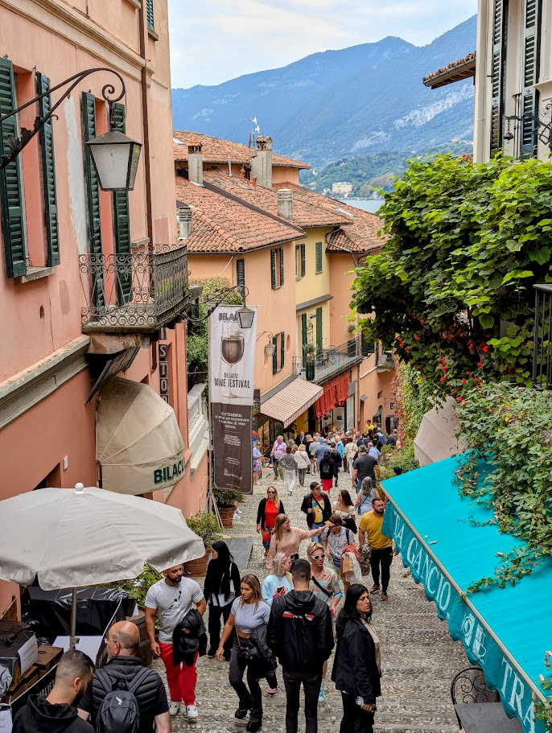

Bellagio

One of the advantages of staying in Como was its excellent train connection to Milan. In just 30 minutes, you can swap serene lake views for the vibrant energy of Italy’s fashion capital. We took the train to Milan twice to visit the two iconic Milan landmarks in the heart of Milan: Milan Cathedral (Duomo di Milano) and the Galleria Vittorio Emanuele II . The Duomo is a stunning example of Gothic architecture, while the Galleria is a beautiful and historic shopping arcade. They are located adjacent to each other in Piazza del Duomo, making them easy to visit together. We didn’t manage to go inside the Cathedral—the lines were overwhelming that day—but instead, we wandered through the Galleria’s shops, pausing to admire the architectural details.

*Travel Tip:* Book Duomo tickets online in advance to skip the long lines..

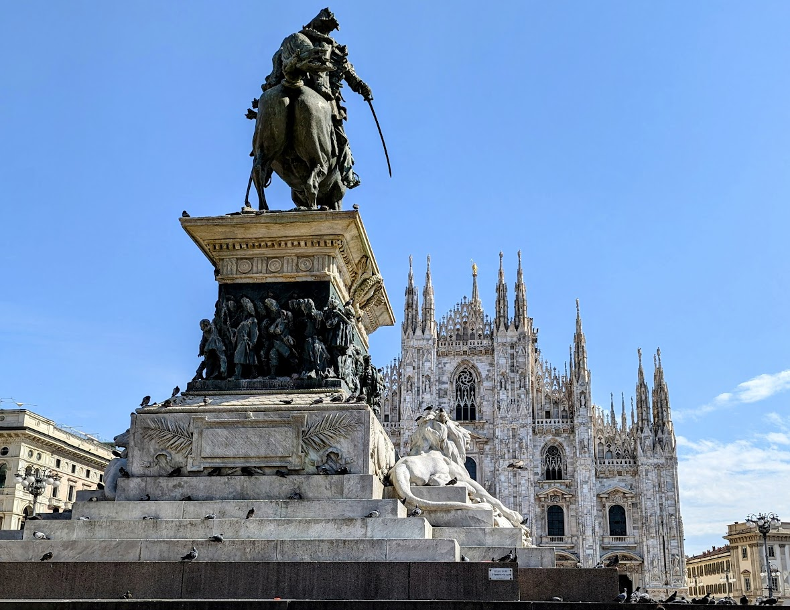

Duomo di Milano

Our week at Lake Como was nothing short of magical. The region captured our hearts with its dramatic scenery, charming towns, and relaxed pace of life. The apartment in Como provided the perfect blend of comfort and convenience, allowing us to truly feel like locals. We wholeheartedly recommend a week-long trip to Lake Como for any traveler seeking a perfect blend of natural beauty, cultural exploration, and Italian charm.

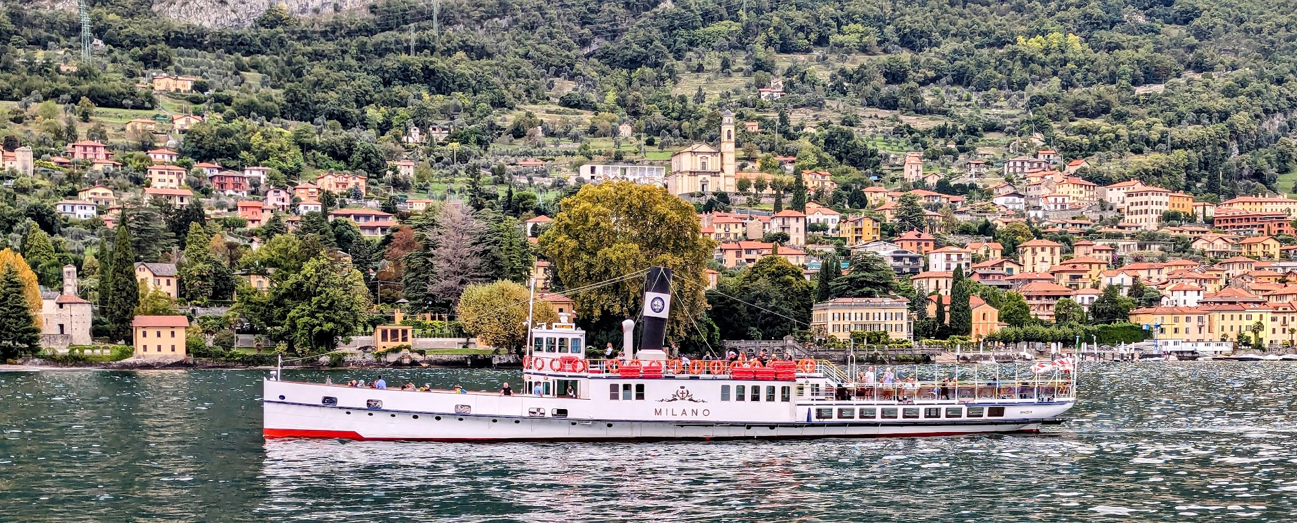

Lake Como Ferries